1.

Using the Iceberg Tool described by Richard Karash (2018), events, patterns, and underlying structures of Case Study 1 can be identified.

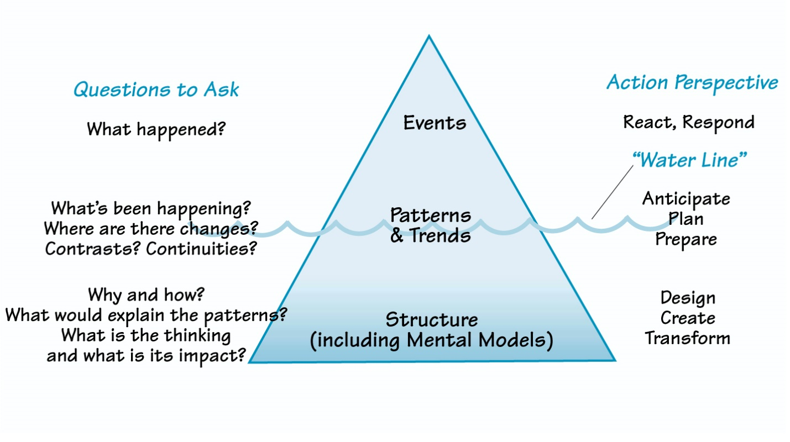

Figure : Iceberg Tool

There are several key events that occur in Case Study 1, the first of these is when the organic farm was first created using small tracts of land. The next key event is when the owners started selling at local farmer’s markets, which increased awareness of their products. After this, local shops and restaurants began to buy and resell the products too which led to more pressure to produce higher quantities. Another key event is using money from savings to expand the farm, purchase additional equipment, increase power and a new barn. Two more key events were using credit cards and then taking out a mortgage on the farm to keep up with expanding financial charges. The final key event is when Calla decided to get a job away from the farm.

Patterns that can be seen in the case study include every time that more customers are found, then more produce is required, and once production is increased to keep up, more customers want the produce as it is more visible. Another pattern involves the debt. The more credit cards and mortgages are relied upon to help the cash flow problem, then the higher the repayments are, adding to the overall debt problems.

The underlying structure that caused these events and patterns start with the initial size of the farm. It started out too small, with not enough workers, power or equipment to sustain the number of customers being sold to. Another underlying structural issue is that the finances were not in place for the expansion.

2.

A Behavior Over Time graph can be used to analyze data over time and are useful for visualizing connections (Daniel Kim, 2018)

Figure : Behavior Over Time Graph for Case Study 1

Figure 2 shows the Behavior Over Time graph that best describes Case Study 1. It clearly shows the steep increase in debt due to the use of credit cards and a new mortgage to expand the business. Whilst this does increase sales and causes a sharp spike in profits initially, overall profits are falling due to the increase in payments.

3.

The Iceberg Tool and Behavior Over Time graph both show that one of the underlying issues with the case study that connects with many of the other events and patterns is financial. The farm started out small but needed to expand in order to satisfy the higher number of customers. However, to achieve this, loans were required, and this has led to an increase in payments, causing a decrease in profits. It would seem that expansion may have occurred too fast, if it has been done at a slower pace then it could have been easier to pay off smaller loans before moving on to the next project. This probably would have meant that the spike in profits seen when the major expansion occurred may not have been so large, but quite possibly would have meant higher profits in the long run. There is also a good possibility that Calla would not have had to leave the business they helped create and find a job elsewhere.

# References

Karash, R. (2018). *How to see "structure*.*"* The Systems Thinker. <https://thesystemsthinker.com/how-to-see-structure/>

Kim, D. (2018). Behavior over time diagrams: Seeing dynamic interrelationships. The Systems Thinker. https://thesystemsthinker.com/behavior-over-time-diagrams-seeing-dynamic-interrelationships/